The Tickled Trout
Christmas Party Menu

Starters
Chicken liver parfait, Sudbrook russet apple, port, oat biscuit
Smoked mackerel paté, pickled beetroots, fennel biscuit
Seasonal velouté, warm potato bread
Ham hock scotched hen’s egg, chorizo mayonnaise
Our wicked garlic dough balls (available vegan)

Mains
Slow roasted Highfield House beef, roasted beef dripping carrot, mash potato
Hall farm Barlow herbed turkey breast, date and chestnut stuffing, garlic roasted root veg
Looe Day Boat skate wing with scallop farce, crushed potatoes, sauce grenoble
Roasted root veg pithivier, goat’s cheese cream sauce
The Tickled Trout Xmas pizza, marinated turkey, pigs in blankets, parsnip, cranberry, sprouts

Dessert
Peanut semi-fredo, caramelised bananas
The Tickled Trout’s famous fruit Clootie, gingerbread ice cream
Dark chocolate delice, chocolate cremeux, foraged berries
British Isles artisan cheese and biscuits (supplement)

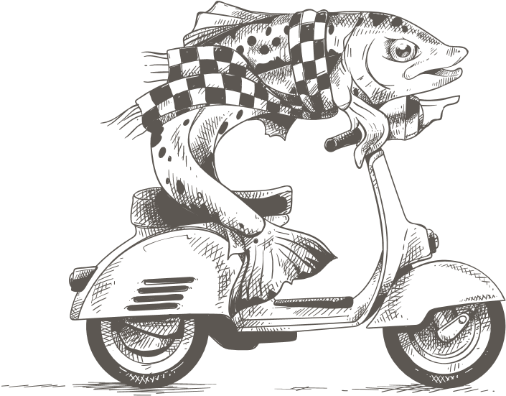
2 Course - £25.95
3 Course - £29.95

Deliciously Derbyshire
Call: 0114 289 1111 Email: dine@tickledtroutbarlow.com

